PHASE 1 – CREATING A CUSTOM APPLICATION
Employee Raise Issue – Record Producer & Service Portal Integration

Description
This phase focuses on creating a custom ServiceNow application to support the Employee Raise Issue process. It establishes the application scope and the basic structure required for further development.

1. Create an Application
- Navigate to All menus → App Engine → ServiceNow Studio.
- Click Create and select App.
- Enter the application name as Employee Center.
- Set Scope to Scoped.
- Click Continue.
- Return to the home screen and reload the instance.
- Verify that Employee Center appears as the current application.

Configuration / Field Details
Field / Configuration | Value
Application Name | Employee Center
Scope | Scoped
ServiceNow Studio – Create Application
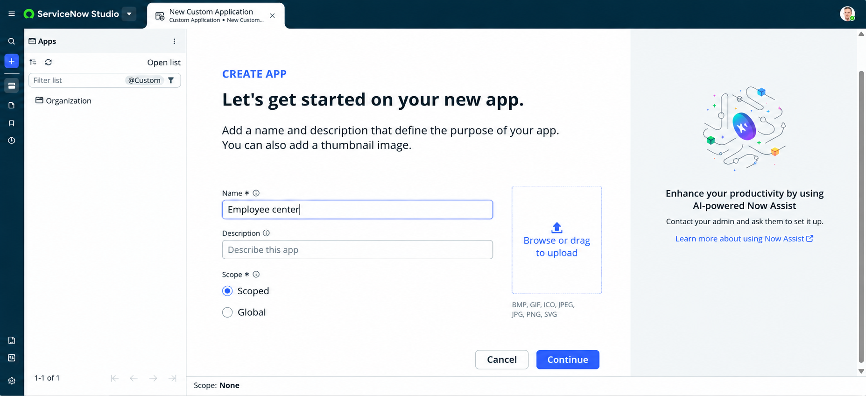

Employee Center shown as Current Application 